CTM-I Use Case

Trade Message Browse

Version 0.1

Use Case Name | Trade Message Browse
Actor | Broker, Firm User, Market Ops, Ops, App Support
Pre-conditions /Assumptions | User has Browser and is aware of the http path to the application.  User has successfully logged into the CTM-I application.  User has the right role to see the menu options.
Post Conditions | None
Screenshot | 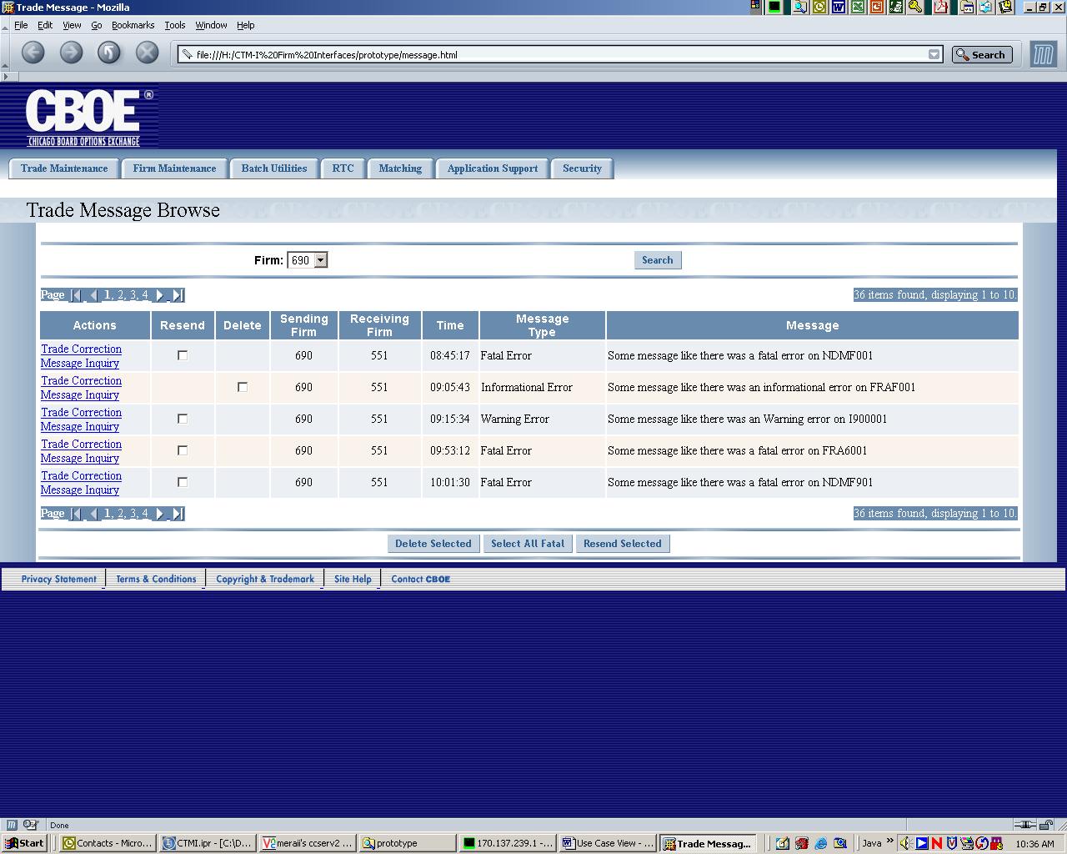
Flow of Events | - User selects “Trade Message Browse” from the menu.  - The Trade Message for the user authorized firms will be requested from CTM-R  - Trade Message Browse screen appears with data  - User can enter data in the following fields  - Firm  - The list of firms is limited by security  - Users with permissions to select any firm have all firms  - Users with limited firms can select firms they are authorized to see.  - The list of Messages will contain the following fields  - Sending Firm  - Receiving Firm  - Time  - Message Type  - Message  - All the messages related to firm are displayed 10 records at a time.  - Standard paging function is available  - User will be able to perform a Trade Correction action on each message. The correction action will take the user to the Trade Correction use case  - User will be able to perform an Allocation action on each trade. The allocation action will take the user to the Trade Allocation use case  - Only Informational messages will have the delete function, all other messages will have only resend function.  - User will be allowed to mark a row for resend.  - User will be allowed to mark a row for delete.  - User will be able to select all fatal messages for resend. This will mark all fatal messages in the results, not just the ones on the screen.  - User will be able to press a button to resend the checked messages. A confirmation pop-up will appear with the number of messages that are going to be resent.  - User will be able to press a button to delete the checked messages. A confirmation pop-up will appear with the number of messages that are going to be deleted.
Alternative Path

